Project Design Phase-II
Data Flow Diagram & User Stories

Date | 31 January 2025
Team ID
Project Name | Cab Booking
Maximum Marks | 4 Marks

Data Flow Diagrams:
The Data Flow Diagram (DFD) represents the flow of information in the Cab Booking System. It shows how users register, log in, and book a cab through the application. The booking details are stored in the database, and the administrator manages bookings by accepting or rejecting requests. Finally, the updated booking status is sent back to the user.
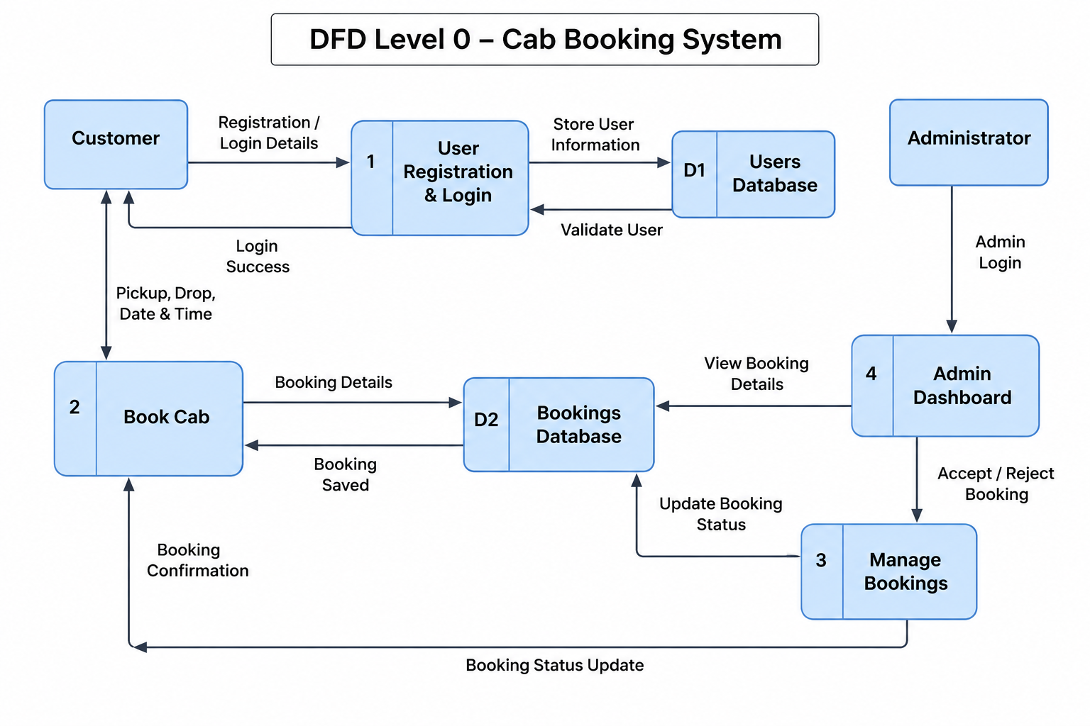
• User registers or logs into the Cab Booking System.
• User enters the pickup location, drop location, date, and time to book a cab.
• The booking details are stored in the MongoDB database.
• The administrator views the booking request and accepts or rejects it.
• The updated booking status is sent back to the user and displayed on the application.

User Stories
Use the below template to list all the user stories for the product.
User Type | Functional Requirement (Epic) | User Story Number | User Story / Task | Acceptance criteria | Priority | Release
Customer (Web User) | Registration | USN-1 | As a user, I can register by entering my name, email, and password. | User account is created successfully and login is enabled. | High | Sprint-1
Customer (Web User) | Login | USN-2 | As a user, I can log in using my email and password. | User is redirected to the Home Dashboard after successful login. | High | Sprint-1
Customer (Web User) | Book Cab | USN-3 | As a user, I can enter pickup and drop locations to book a cab. | Booking is stored successfully and confirmation is displayed. | High | Sprint-1
Customer (Web User) | View Bookings | USN-4 | As a user, I can v cabs.iew all my booke | My Bookings page displays all previous and current bookings. | High | Sprint-1
Customer (Web User) | Cancel Booking | USN-5 | As a user, I can cancel my pending booking. | Booking status changes to "Cancelled". | Medium | Sprint-2
Administrator | View Bookings | USN-6 | As an administrator, I can view all customer bookings. | Admin dashboard displays all booking records. | High | Sprint-1
Administrator | Accept Booking | USN-7 | As an administrator, I can accept a customer booking. | Booking status changes to "Accepted". | High | Sprint-2
Administrator | Reject Booking | USN-8 | As an administrator, I can reject a customer booking. | Booking status changes to "Rejected". | Medium | Sprint-2
Administrator | Manage Users | USN-9 | As an administrator, I can view registered users. | Registered users are displayed correctly. | Medium | Sprint-2
Customer Care Executive | Customer Support | USN-10 | As a customer care executive, I can assist customers with booking-related issues. | Customer issues are resolved and booking information is available. | Low | Sprint-3

